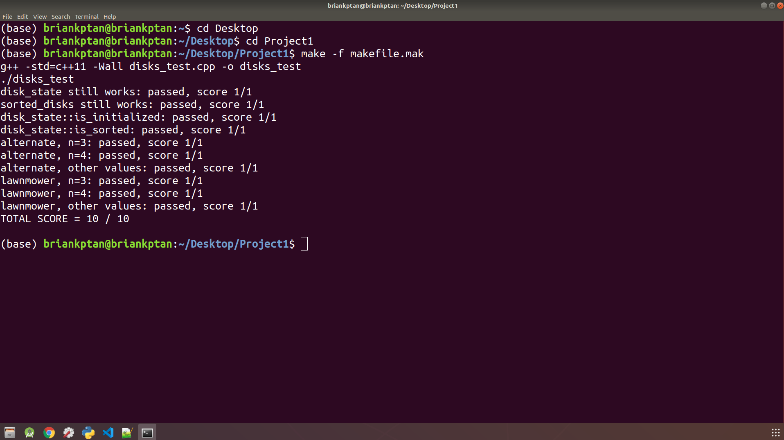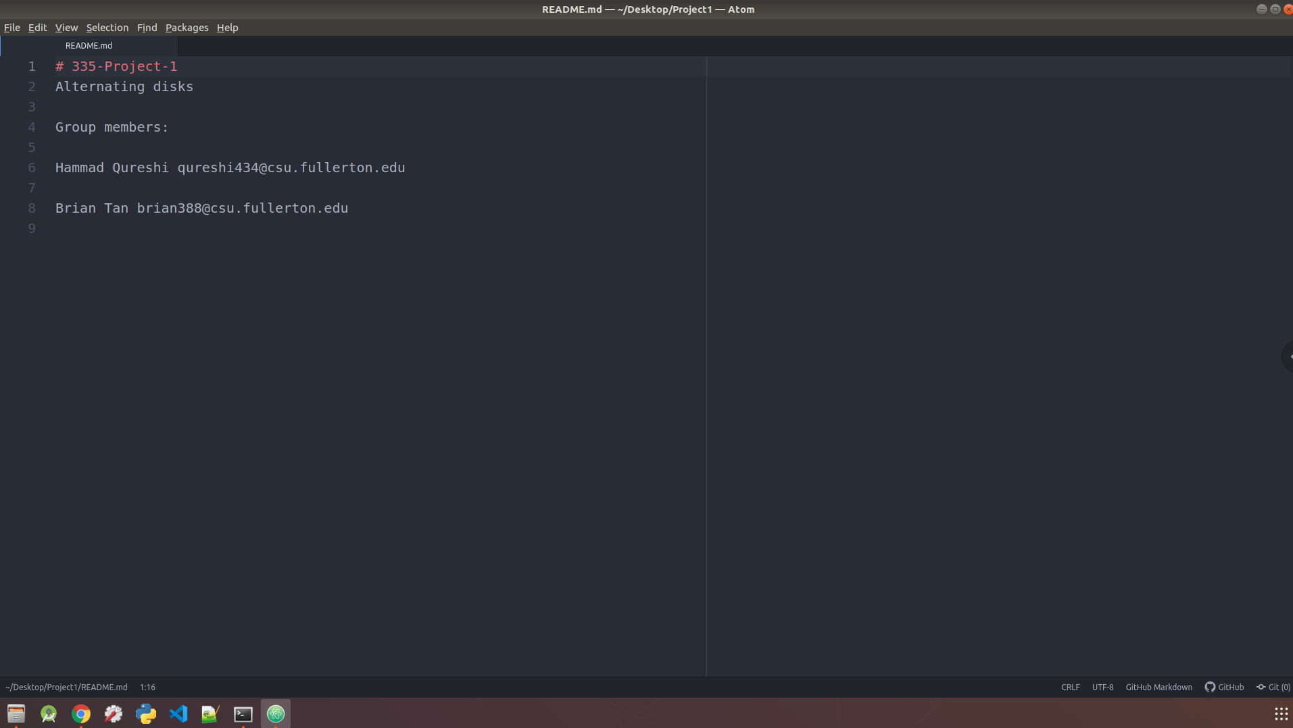

**Project 1**

**Pseudocode for Alternate Algorithm**

sort_alternate(before)

after = before // 1tu

swap_count = 0 //1tu

run_count = 0 //1tu

if after.issorted() == true then // 8n + 16 tu

return sequence unchanged

else

if after.is_initialized() == true then // $\frac{5n}{2}+ 7$ tu

for i = 0 to n-1 do //outer for loop

if run_count % 2 != 0 then //2 tu

for j = 0 to 2n-1, step 2, do //inner loop 1

if color[j] != color[j+1] then //2tu

swap() //5tu

swap_count++ //1tu

endif

endfor

else

for j = 1 to 2n-2, step 2, do //inner loop 2

if color[j] != color[j+1] then //2tu

swap() //5tu

swap_count++ //1tu

endif

endfor

endif

run_count++ //1tu

endfor

else

return sequence unchanged

endif

endif

*// is_initialized() function step count calculated to be $\frac{5n}{2}+ 7$ tu*

*// is_sorted() function step count calculated to be 8n + 16 tu*

*//swap() function determined to be 5tu*

**Proof and Time Complexity for Alternate Algorithm**

(Independent for loops)

outer for loop:

using $\frac{end-start}{step}$ + 1 :

+ 1 = $n$

inner for loop 1:

+ 1 = n+ $\frac{1}{2}$

multiply with the if statement time units: 8( n + $\frac{1}{2}$) = 8n + 4 //2tu + 5tu + 1tu = 8tu

inner for loop 2:

+ 1 = n- $\frac{1}{2}$

multiply with the if statement time units: 8( n- $\frac{1}{2}$) = 8n - 4

Combined:

outer for loop * (2 + max(inner loop 1, inner loop 2) + 1 ) //+1 because of the run_count increment

= n * (2 + max(8n + 4, 8n - 4) + 1)

= $n$* (2 + (8n + 4) + 1)

= * (8n + 7)

= 8n2 +

Add the time units outside the outer loop:

8n2 + 7n + 3 + + 8n + 16

= 8n2+ + 26

highest power is 2. Therefore, algorithm efficiency class is O(n2).

Proof by definition

Prove 8n2+ + 26 ∈ O(n2)

choose C > 0 and a value n­0 >= 0 such that:

8n2+ + 26 <= C * n2 ∀ n >= n0

choose C = 8 + + 26 ≅ 52

8n2+ + 26 <= 52n2, true for n >= 1

choose n0 = 1

∴ 8n2+ + 26 ∈ O(n2)

**Pseudocode for Lawnmower Algorithm**

sort_lawnmower(before)

after = before //1tu

swap_count = 0 //1tu

temp_n = total_n - 1 //2tu

if after.issorted() == true then //*8n + 16 tu*

return sequence unchanged

else

if after.is_initialized() == true then // $\frac{5n}{2}+ 7$ *tu*

for i = 0 to n-1 do //outer loop

for j = i to 2n-1, step 2, do //inner loop 1

if color[j] != color[j+1] then //2tu

swap() //5tu

swap_count++ //1tu

endif

endfor

temp_n-- //1tu

if temp_n < i then //1tu

for k = 2n-1 down to i, step 2, do //inner loop 2

if color[k] != color[k-1] then //2tu

swap() //5tu

swap_count++ //1tu

endif

endfor

endif

endfor

else

return sequence unchanged

endif

endif

*//swap() function determined to be 5tu*

**Proof and Time Complexity for Lawnmower Algorithm**

Proof Time Complexity

(Dependent for loops)

outer for loop:

part of this loop has 1 decrement, and 1 if statement. So multiply by 2tu

$$\sum_{i=0}^{n-1}{2}$$

inner loop 1:

1 if statement with 2tu operations, and carries out 5tu function and 1tu increment. So, 2+5+1= 8tu

since step of 2, use $\frac{end-start}{step}$ + 1.

8 ( $\frac{ 2n-1-i}{2}$ + 1) = 8 (n + $\frac{ 1- i}{2}$)

inner loop 2:

1 if statement with 2tu operations, and carries out 5tu function and 1tu increment. So, 2+5+1= 8tu

since step of -2 use $\frac{end-start}{step}$ + 1.

8 ( $\frac{i-2n-1}{-2}$ + 1) = 8 (n + $\frac{3-i}{2}$)

Combined:

(outer for loop) * (inner loop 1 + inner loop 2)

$\sum_{i=0}^{n-1}{2}$ [8 (n + $\frac{ 1- i}{2}$) + 8 (n + $\frac{3-i}{2}$)]

= $\sum_{i=0}^{n-1}{2}$* 8[(n + $\frac{ 1- i}{2}$) + (n + $\frac{3-i}{2}$)]

= $\sum_{i=0}^{n-1}{16}$ ( 2n + 2 – i ) = $\sum_{i=0}^{n-1}{16}$ ( 2n – i + 2 )

= $\sum_{i=0}^{n-1}{( 32n-16i+32)}$

= $\sum_{i=0}^{n-1}{16n}$- $\sum_{i=0}^{n-1}{16i}$ + $\sum_{i=0}^{n-1}{32}$// $\sum_{i=0}^{n-1}{16i}$ = 16 * 0 + $\sum_{i=1}^{n-1}{16i}$ = 16 ( $\frac{n-1 ( n-1 + 1 )}{2}$)

= 16n(n-1 + 1) - 16 ( $\frac{n-1 ( n-1 + 1 )}{2}$) + 32(n-1 + 1)

= 16n2 – 8n2 – 8n + 32n

= 8n2 – 8n + 32

Add time units outside of outer loop:

8n2 – 8n + 32 + 4 + + 8n + 16

= 8n2 + + 59

highest power is 2. Therefore, algorithm efficiency class is O(n2).

Proof by definition

Prove 8n2 + + 59 ∈ O(n2)

choose C > 0 and a value n0 >= 0 such that:

8n2 + + 59 <= C * n2 ∀ n >= n0

choose C = 8 + + 59 ≅ 70

8n2 + + 59 <= 70n2 , true for n >= 1

choose n0 = 1

∴ 8n2 + + 59 ∈ O(n2)